**Ideation Phase**

**Define the Problem Statements**

|  |  |
| --- | --- |
| Date | 31 January 2025 |
| Team ID | LTVIP2025TMID37239 |
| Project Name | Health AI -intelligent healthcare assistant using IBM granite |
| Maximum Marks | 2 Marks |

**Customer Problem Statement Template:**

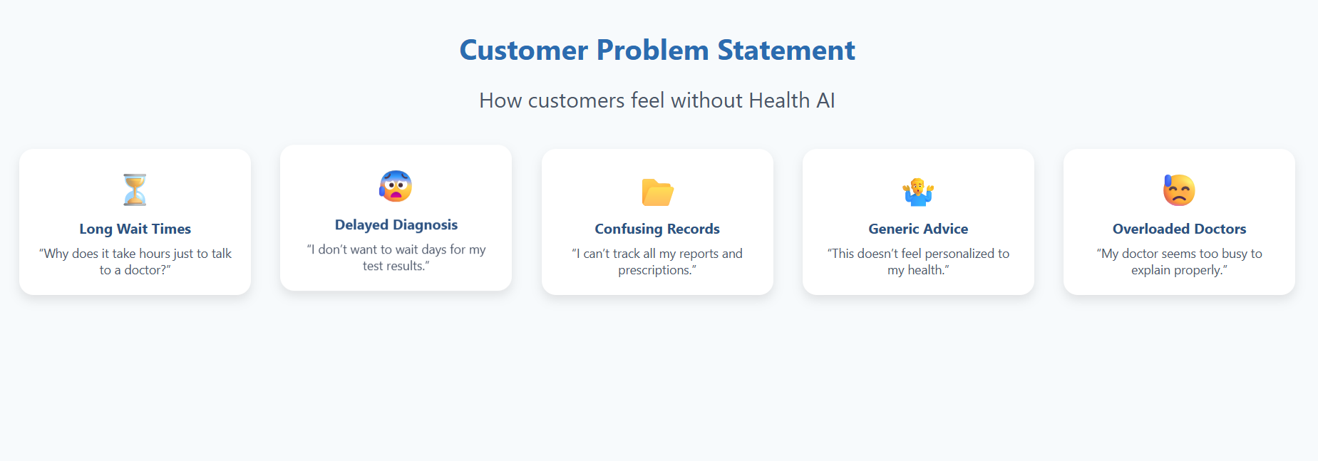

|  |  |  |  |  |  |
| --- | --- | --- | --- | --- | --- |
| **Problem Statement (PS)** | **I am (Customer)** | **I’m trying to** | **But** | **Because** | **Which makes me feel** |
| PS-1 | Patient A | get a quick diagnosis for my symptoms | I have to wait days or weeks for appointments and test results | the healthcare system is overloaded and slow | frustrated, worried, and helpless |
| PS-2 | Patient B | keep track of my medical reports and treatments | my health records are scattered and hard to access | hospitals use different systems and paper files | confused, stressed, and unsupported |